Appendix
Activity Sheet of How to Compare/Contrast using a Narrative Essay

ACTIVITY SHEET: How to Compare/Contrast using a Narrative Essay

Your Name: _______________________________

STEP 1: Read the essay
STEP 2: After reading the essay, answer the following response questions in not more than 1-2 lines.
Responsive questions:
● Which character do you find most interesting, and which character do you want to choose for compare/contrast?
________________________________________________________________________
________________________________________________________________________
● Why are you interested in that character?
________________________________________________________________________ ________________________________________________________________________
● What are the most salient characteristics of that character?
________________________________________________________________________ ________________________________________________________________________
● What are the positive and/or negative characteristics of this character?
________________________________________________________________________ ________________________________________________________________________

STEP 3: Fill in all the responses of Step 2 In the diagram below. The description of each response should only be in a few words.
Character You
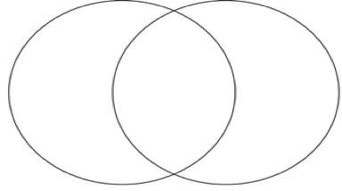
Similarities (Center Part)
Dissimilarities Dissimilarities

STEP 4: Based on your information in the Venn diagram, write a short response (not more than 250 words) that compares and contrasts who the character is to who you are?
_________________________________________________________________________________________________________________________________________________________________________________________________________________________________________________________________________________________________________________________________________________________________________________________________________________________________________________________________________________________________________________________________________

